

Practices for Secure Software Report

Table of Contents
Document Revision History 3
Client 3
Instructions 3
Developer 4
1. Algorithm Cipher 4
2. Certificate Generation 4
3. Deploy Cipher 4
4. Secure Communications 4
5. Secondary Testing 4
6. Functional Testing 4
7. Summary 4
8. Industry Standard Best Practices 4

Document Revision History

Version | Date | Author | Comments
1.0 | 8-22-2026 | DeMorris Duncan

Client



Instructions

Submit this completed practices for secure software report. Replace the bracketed text with the relevant information. You must document your process for writing secure communications and refactoring code that complies with software security testing protocols.

- Respond to the steps outlined below and include your findings.
- Respond using your own words. You may also choose to include images or supporting materials. If you include them, make certain to insert them in all the relevant locations in the document.
- Refer to the Project Two Guidelines and Rubric for more detailed instructions about each section of the template.

Developer
DeMorris Duncan

Algorithm Cipher

For Artemis Financial, I recommend using the Advanced Encryption Standard (AES) with a 256-bit key to protect sensitive client and financial information. AES is a symmetric encryption algorithm, which means that the same secret key is used to encrypt and decrypt the information. AES is widely used because it provides strong security while still being efficient enough for modern software applications. Using AES-256 would provide Artemis Financial with a strong level of protection for confidential information that needs to be encrypted.

For the checksum verification required in this project, I implemented SHA-256. SHA-256 is a cryptographic hash function rather than an encryption algorithm. It takes the original data and generates a fixed 256-bit hash value, which is normally represented as 64 hexadecimal characters. The checksum can be used to verify data integrity because changing the original information will result in a different hash value. This allows Artemis Financial to determine whether information has been modified during a transfer. SHA-256 is more appropriate for this purpose than older algorithms such as MD5 or SHA-1, which have known security weaknesses.

Secure cryptographic systems also depend on proper management of keys and random values. Because AES is symmetric, its secret key must be protected from unauthorized access. Asymmetric encryption works differently because it uses a public key and a private key instead of one shared secret key. This type of cryptography is commonly used as part of establishing secure communications. Cryptographically secure random numbers are also important when generating encryption keys and values such as initialization vectors or nonces. Predictable values could weaken an otherwise strong encryption algorithm.

Encryption algorithms have continued to improve as older algorithms have become vulnerable to increases in computing power and advances in cryptanalysis. DES was once widely used, but its relatively small key size eventually made it unsuitable for protecting modern sensitive information. AES was developed as a stronger replacement and remains an important standard for modern encryption. Hashing algorithms have evolved as well. MD5 and SHA-1 are no longer appropriate for security-sensitive integrity verification because weaknesses have been discovered in both. SHA-256, which is part of the SHA-2 family, provides much stronger protection against these attacks and is appropriate for the checksum verification implemented in the Artemis Financial application.

Certificate Generation
A self-signed certificate was generated using the Java Keytool to support secure HTTPS communication for the Artemis Financial application. An RSA 2048-bit key pair was generated and stored in a PKCS12 keystore named artemisfinancial.p12. The certificate was then exported from the keystore as artemisfinancial.cer. This certificate is used as part of establishing encrypted communication between the application and the client.
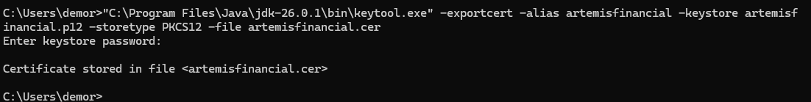Figure 1. Successful export of the Artemis Financial self-signed certificate as a CER file.

Deploy Cipher
The application was refactored to implement a SHA-256 cryptographic hash algorithm for checksum verification. I created a /hash endpoint that uses Java's MessageDigest class to generate a SHA-256 hash from a unique data string. The resulting hash is converted into a hexadecimal checksum and displayed with the original data. This provides a method of verifying data integrity because any change to the original data would produce a different checksum.

The application successfully generated a SHA-256 checksum for the unique data string, "DeMorris Duncan - Artemis Financial Secure Transfer 2026." The successful output demonstrates that the checksum functionality was implemented correctly.

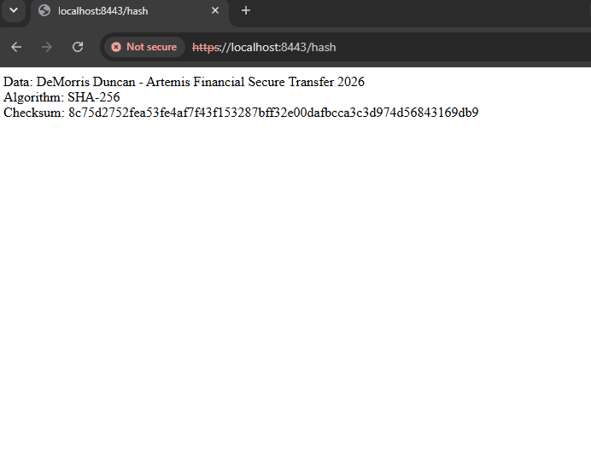
Figure 2. SHA-256 checksum verification generated by the refactored Artemis Financial application.

Secure Communications
Secure communication was enabled by refactoring the application's configuration to use HTTPS instead of HTTP. The application was configured to run on port 8443 and use the PKCS12 keystore containing the self-signed certificate that was generated for Artemis Financial. The keystore information, certificate alias, and required SSL settings were added to the application.properties file.

After the configuration changes were completed, the application was compiled and executed. The /hash endpoint was successfully accessed using https://localhost:8443/hash, confirming that the application was communicating through HTTPS. Using HTTPS provides an additional layer of security by encrypting information transmitted between the client and the web application.


Figure 3. Artemis Financial application running through HTTPS on port 8443 using the generated self-signed certificate.

Secondary Testing
Secondary static testing was completed using the OWASP Dependency-Check Maven plug-in. After the security changes were implemented, the refactored application was compiled and tested successfully. The Maven build completed successfully, confirming that the project could be built with the implemented security changes.

Dependency-Check was then used to scan the refactored application for known dependency vulnerabilities. To determine whether the refactoring introduced any new dependency vulnerabilities, I also performed the same Dependency-Check scan on a clean copy of the original Project Two code base using the same version of the Dependency-Check plug-in. The findings from the original and refactored applications matched. This comparison demonstrated that the SHA-256 checksum, certificate, keystore, and HTTPS changes did not introduce additional dependency vulnerabilities.

The vulnerabilities identified by Dependency-Check were associated with dependencies that were already included in the original application. The checksum implementation used Java's built-in MessageDigest functionality and did not require adding another third-party dependency. Based on the comparison between the original and refactored applications, no new dependency vulnerabilities were introduced by the security enhancements.

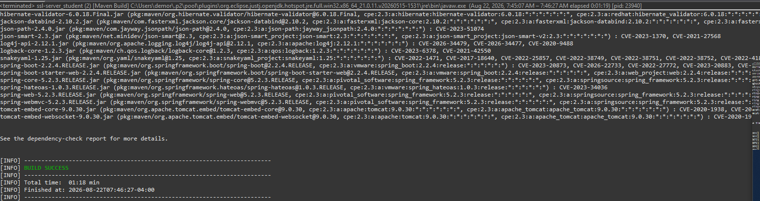
Figure 4. Successful Maven build of the refactored Artemis Financial application.

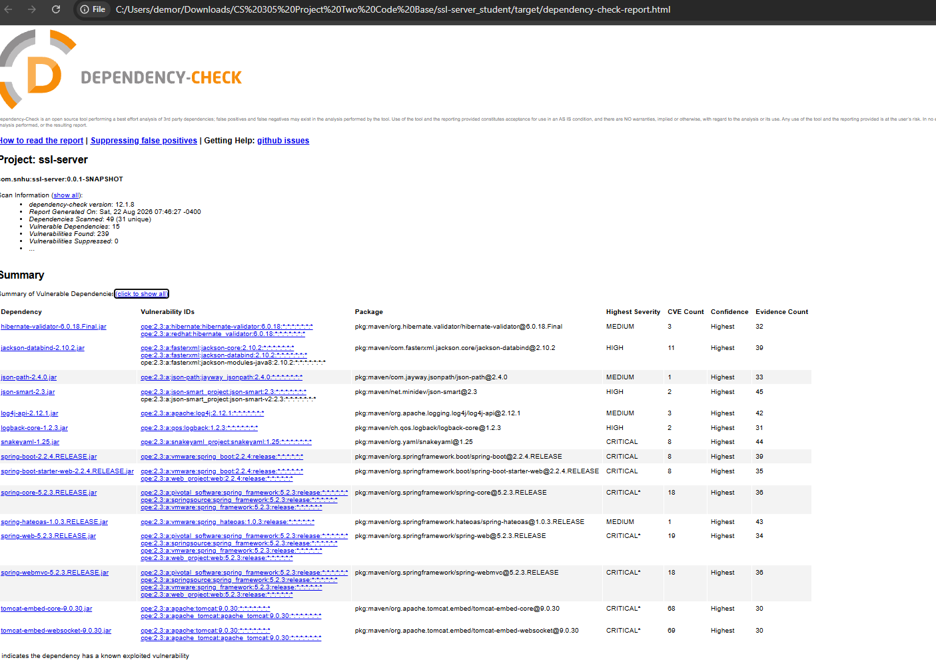
Figure 5. OWASP Dependency-Check results for the refactored Artemis Financial application.

Functional Testing
I manually reviewed and tested the refactored application for syntactical, logical, and security vulnerabilities. For syntactical testing, I reviewed the Java code for problems with imports, method declarations, braces, statements, and other Java syntax. The application compiled and executed successfully without syntax or runtime errors.

For logical testing, I verified that the /hash endpoint performed its intended function. The application processed the unique data string and successfully generated a SHA-256 checksum. The browser displayed the original data, the SHA-256 algorithm, and the resulting checksum, demonstrating that the checksum functionality operated as expected.

For security testing, I verified that SHA-256 was used for checksum generation rather than an outdated hash function such as MD5 or SHA-1. I also verified that the application was configured to use HTTPS on port 8443 with the generated PKCS12 keystore and self-signed certificate. The application successfully started with HTTPS enabled and allowed the /hash endpoint to be accessed through an HTTPS connection. Based on the manual review and functional testing, the security enhancements operated correctly without preventing the existing application from executing successfully.

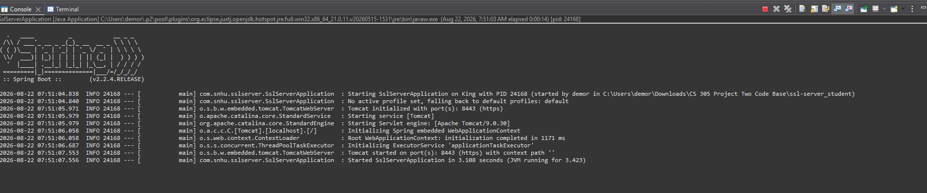
Figure 6. Successful execution of the refactored Artemis Financial application on HTTPS port 8443.

Summary

The Artemis Financial application was refactored to improve data integrity and secure communication. The primary changes included implementing SHA-256 checksum verification, generating a self-signed certificate and PKCS12 keystore, and configuring the application to communicate through HTTPS on port 8443. After these changes were completed, the application was tested using OWASP Dependency-Check and manual functional testing to verify that the security enhancements worked correctly and did not introduce additional dependency vulnerabilities.

The refactoring addressed several areas of security considered during the vulnerability assessment process. Cryptography was addressed by using SHA-256 to create a checksum for verifying the integrity of transferred data. Secure communication was addressed by replacing HTTP communication with HTTPS and configuring the application to use a certificate and keystore. The application's dependencies were also examined using static testing to identify known vulnerabilities in third-party components. Finally, manual code review and functional testing were used to identify possible syntactical, logical, and security problems in the refactored application.

Multiple layers of security were added rather than relying on a single security control. SHA-256 provides a method for detecting changes to data, while HTTPS protects information as it travels between the client and the application. The certificate and keystore support the encrypted HTTPS connection, while Dependency-Check provides another layer by identifying known vulnerabilities associated with software dependencies. Manual testing provides an additional check that the application functions correctly after the security changes. Together, these controls provide a defense-in-depth approach that improves the protection of Artemis Financial's client and financial information.

Industry Standard Best Practices

Industry standard best practices were applied throughout the refactoring process to maintain and improve the security of the Artemis Financial application. Instead of creating a custom cryptographic algorithm, I used Java's established security libraries and the SHA-256 hashing algorithm for checksum verification. HTTPS was implemented to protect information transmitted between the client and the application, and a certificate and PKCS12 keystore were used to support the secure connection. Using established cryptographic standards and trusted security APIs reduces the possibility of introducing weaknesses through custom security implementations.

Security testing was also an important part of maintaining the application's existing security. OWASP Dependency-Check was used to identify known vulnerabilities associated with the application's dependencies. The results from the original application were compared with the results from the refactored application to verify that the security changes did not introduce additional dependency vulnerabilities. Manual code review and functional testing were also performed to identify syntactical, logical, and security problems. This combination of automated and manual testing provides stronger coverage than relying on only one testing method.

Applying secure coding best practices is valuable to Artemis Financial because the company is responsible for protecting sensitive client and financial information. Security vulnerabilities can result in unauthorized access, altered information, financial losses, service disruptions, and damage to customer trust. Using secure communication, data-integrity verification, established cryptographic standards, dependency testing, and manual code review helps reduce these risks. Continuing to apply these practices throughout the software development life cycle can help Artemis Financial maintain a more secure and reliable application as the software is updated in the future.

